Project Information

**DA Assignment- 2**

**Team ID:** LTVIP2025TMID48627

**Team Size:** 4

**Team Leader:** Y Mahaboob Basha

**Team member:** Shamshunnisa Makam

**Team member:** Teneti Saranya

**Team member:** T Sri Kanth

ID: 22F21A3245

INSTITUTION: Gates Institute of Technology

Project Title: Measuring the Pulse of Prosperity: An Index of Economic Freedom Analysis

**Visualization Screenshots**

* **Donut Chart – Branch-wise Sales Contribution**

**Caption: this is made by me as gif type…**

This donut chart displays the total sales contribution from each branch (A, B, C). The center highlights the overall sales volume while the segments show the proportional share by branch.

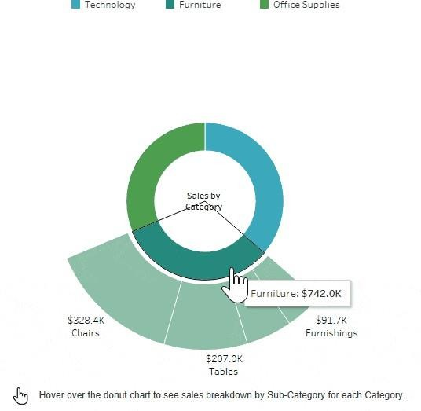

**Area Chart – Monthly Sales Trend Caption:**

This area chart visualizes the total sales over the three months (January to March 2019). It uses color

shading to show branch-level contributi

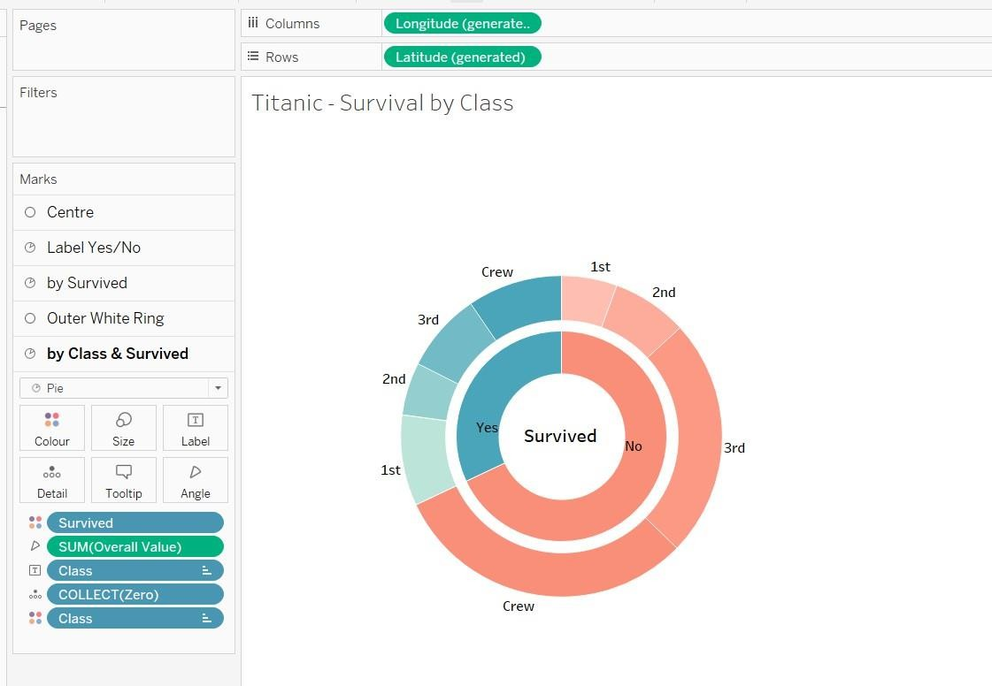on across time.

**Text Table – Product Line Sales Summary Caption: converted into gif by me…**

This text table provides a detailed breakdown of sales, quantity sold, gross income, and average customer rating per product line and customer type.

.

**Word Cloud – Most Purchased Product Lines**

**Caption:**

This word cloud illustrates the popularity of different product lines based on the number of items purchased. Font size reflects quantity sold.

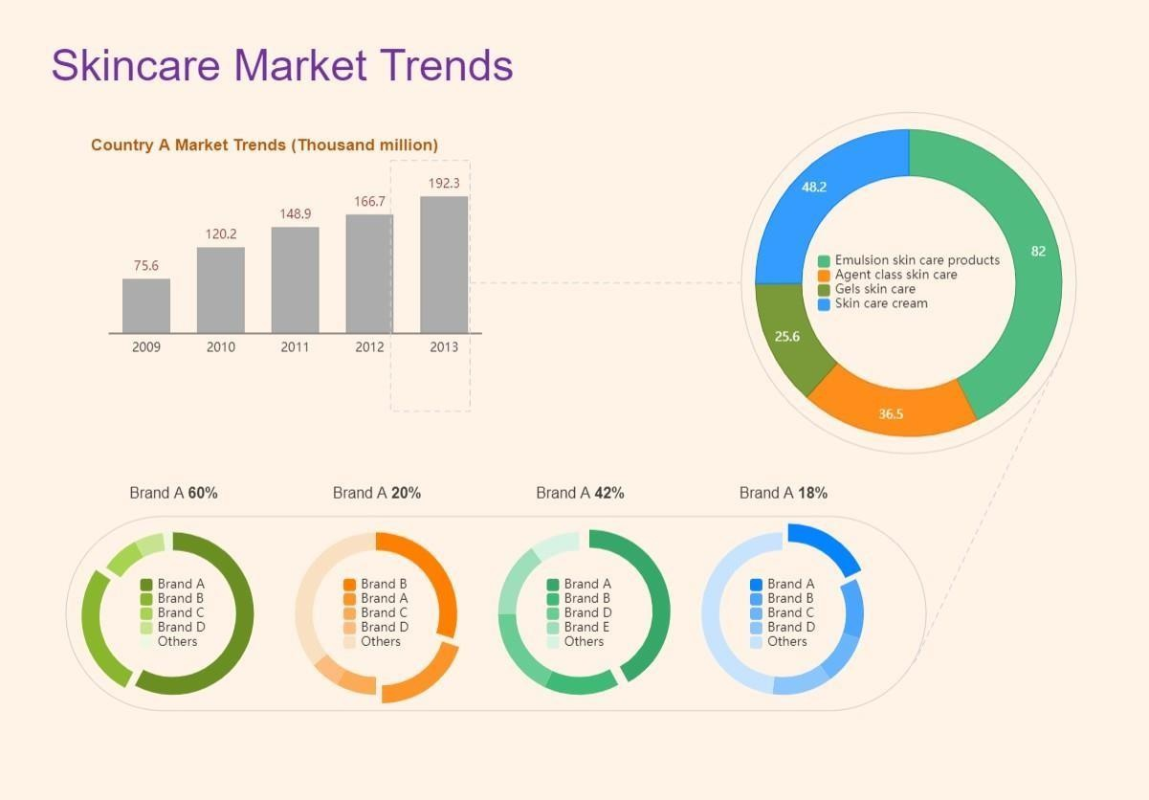

**Funnel Chart – Payment Method Usage Caption:**

This funnel chart visualizes the volume of sales through each payment method. It narrows from the most to least used method.